Introduction
This exercise requires you to know the following aspects of SQL:
CREATE TABLE | Concatenation
SQL Data Types | Formatting dates and numbers
INSERT INTO | Column aliases
SELECT | Simple JOIN statements
WHERE clause | Complex JOIN statements
LIKE and wildcards | Subquery
Exercise 1 – Northwind Queries (40 marks: 5 for each question)
- Write a query that lists all Customers in either Paris or London. Include Customer ID, Company Name and all address fields.
SELECT CustomerID AS "Customer ID", CompanyName AS "Company Name", Address, City, Region, PostalCode AS "Postal Code", Country
FROM Customers
WHERE City = 'Paris' or City = 'London'
In order to complete this query a we had to select , all columns required to answer the following question and because these column still had the title(labels) for the original colunms an alias had to be made for our results table to correct the appearance from the original table. As the query only asked for customers in only paris a codition had to be added in the where statement to bring only the datwa required.
- List all products stored in bottles.
SELECT ProductID AS "Product ID", ProductName AS "Product Name", SupplierID AS "Supplier ID", CategoryID AS "Category ID", QuantityPerUnit AS "Quantity per Unit", UnitPrice AS "Unit Price", UnitsInStock AS "Units in Stock", UnitsOnOrder AS "Units on Order", ReorderLevel AS "Reorder level", Discontinued
FROM Products
WHERE QuantityPerUnit LIKE '%bottles%'

Although the question sounded very simple to bring out only items stored in bottles the condition of us a like statement had to be added which would only search for the phrase bottle in the column quantity per unit
- Repeat question above, but add in the Supplier Name and Country.

SELECT ProductID AS "Product ID", ProductName AS "Product Name", Suppliers.CompanyName AS "Company Name",Suppliers.Country AS "Country", Products.SupplierID AS "Supplier ID",CategoryID AS "Category ID", QuantityPerUnit AS "Quantity per Unit", UnitPrice AS "Unit Price", UnitsInStock AS "Units in Stock", UnitsOnOrder AS "Units on Order", ReorderLevel AS "Reorder level", Discontinued
FROM Products
INNER JOIN Suppliers ON Products.SupplierID=Suppliers.SupplierID
WHERE Products.QuantityPerUnit LIKE '%bottles%'

To complete this question as this was kind of a follow on from the last question most of the data was the same so all that needed to be done was to call supplier name and country from the suppliers table and join it to our existing query to gain our desired result.

- Write an SQL Statement that shows how many products there are in each category. Include Category Name in result set and list the highest number first.
SELECT Categories.CategoryName AS "Category Name", COUNT (p.CategoryID) AS "Products"
FROM Products p
INNER JOIN Categories ON p.CategoryID=Categories.CategoryID
GROUP BY Categories.CategoryName
ORDER BY COUNT (p.CategoryID) DESC

- List all UK employees using concatenation to join their title of courtesy, first name and last name together. Also include their city of residence.
SELECT CONCAT (e.TitleOfCourtesy,' ',e.FirstName,' ',e.LastName,' from',e.City) AS "Employee Name"
FROM Employees e
WHERE e.Country = 'UK

- List Sales Totals for all Sales Regions (via the Territories table using 4 joins) with a Sales Total greater than 1,000,000. Use rounding or FORMAT to present the numbers.
- Count how many Orders have a Freight amount greater than 100.00 and either USA or UK as Ship Country.
SELECT COUNT( * )
FROM Orders
WHERE Freight > 100.0 AND ShipCity = 'USA' or ShipCity = 'UK'

- Write an SQL Statement to identify the Order Number of the Order with the highest amount of discount applied to that order.
Exercise 2 – Create Spartans Table (20 marks – 10 each)
2.1 Write the correct SQL statement to create the following table:
Spartans Table – include details about all the Spartans on this course. Separate Title, First Name and Last Name into separate columns, and include University attended, course taken and mark achieved. Add any other columns you feel would be appropriate.
CREATE TABLE Spartan (
SpartanID varchar(11),
Title varchar(8),
LastName varchar(255),
FirstName varchar(255),
Address varchar(255),
City varchar(255),
Universityattended varchar(255),
coursetaken varchar(255),
markachieved int,
Dateofcompletion Date
);

IMPORTANT NOTE: For data protection reasons do NOT include date of birth in this exercise.
2.2 Write SQL statements to add the details of the Spartans in your course to the table you have created.
INSERT INTO Spartan ( SpartanID, Title, LastName, FirstName, Address, City, Universityattended, coursetaken, markachieved, Dateofcompletion)
VALUES ('2','Rev','Rebekah','Rennolds','16 Terrace Itinga','Lisbon','rrennolds1@tinypic.com', 'Universidad Nacional Experimental de la Fuerza Armada','30','2018-07-29'),
('3', 'Mrs', 'Clarance', 'Cash', '4 Anhalt Circle','London', 'ccash2@fema.gov', 'Northern State University','8','2018-09-07'),
('4', 'Ms', 'Chiquia', 'Snowden' ,'28572 Cambridge Trail', 'Shanghai', 'csnowden3@icio.us', 'Azerbaijan Toursim Institute', '86', '2018-08-07'),
('5', 'Mr', 'Horacio', 'Tramel', '12 Dottie Court ','London', 'htramel4@independent.co.uk', 'Hofstra University', '69','2018-09-07'),
('6', 'Mr', 'Trude', 'Antoniewicz', '58 Claremont Park','New York', 'tantoniewicz5@naver.com', 'American International University - Bangladesh' ,'27','2018-09-07'),
('7', 'Mrs', 'Venus', 'Biskup', '26688 Lakeland Lane','New York', 'vbiskup6@nydailynews.com', 'United States International University', '16','2018-09-07'),
('8', 'Ms', 'Kimmie', 'Reinbech', '06 Westridge Street','New York','kreinbech7@netlog.com', 'Wuyi University', '75', '2018-03-29'),
('9', 'Mrs', 'Tawsha', 'Saket', '45055 Hoffman Place','Lisbon', 'tsaket8@ucoz.com', 'European University at St.Petersburg', '47', '2018-09-27'),
('10', 'Ms', 'Zaria' , 'Magill', '91090 Parkside Point','New York', 'zmagill9@archive.org', 'Eastern University', '85', '2018-10-27')

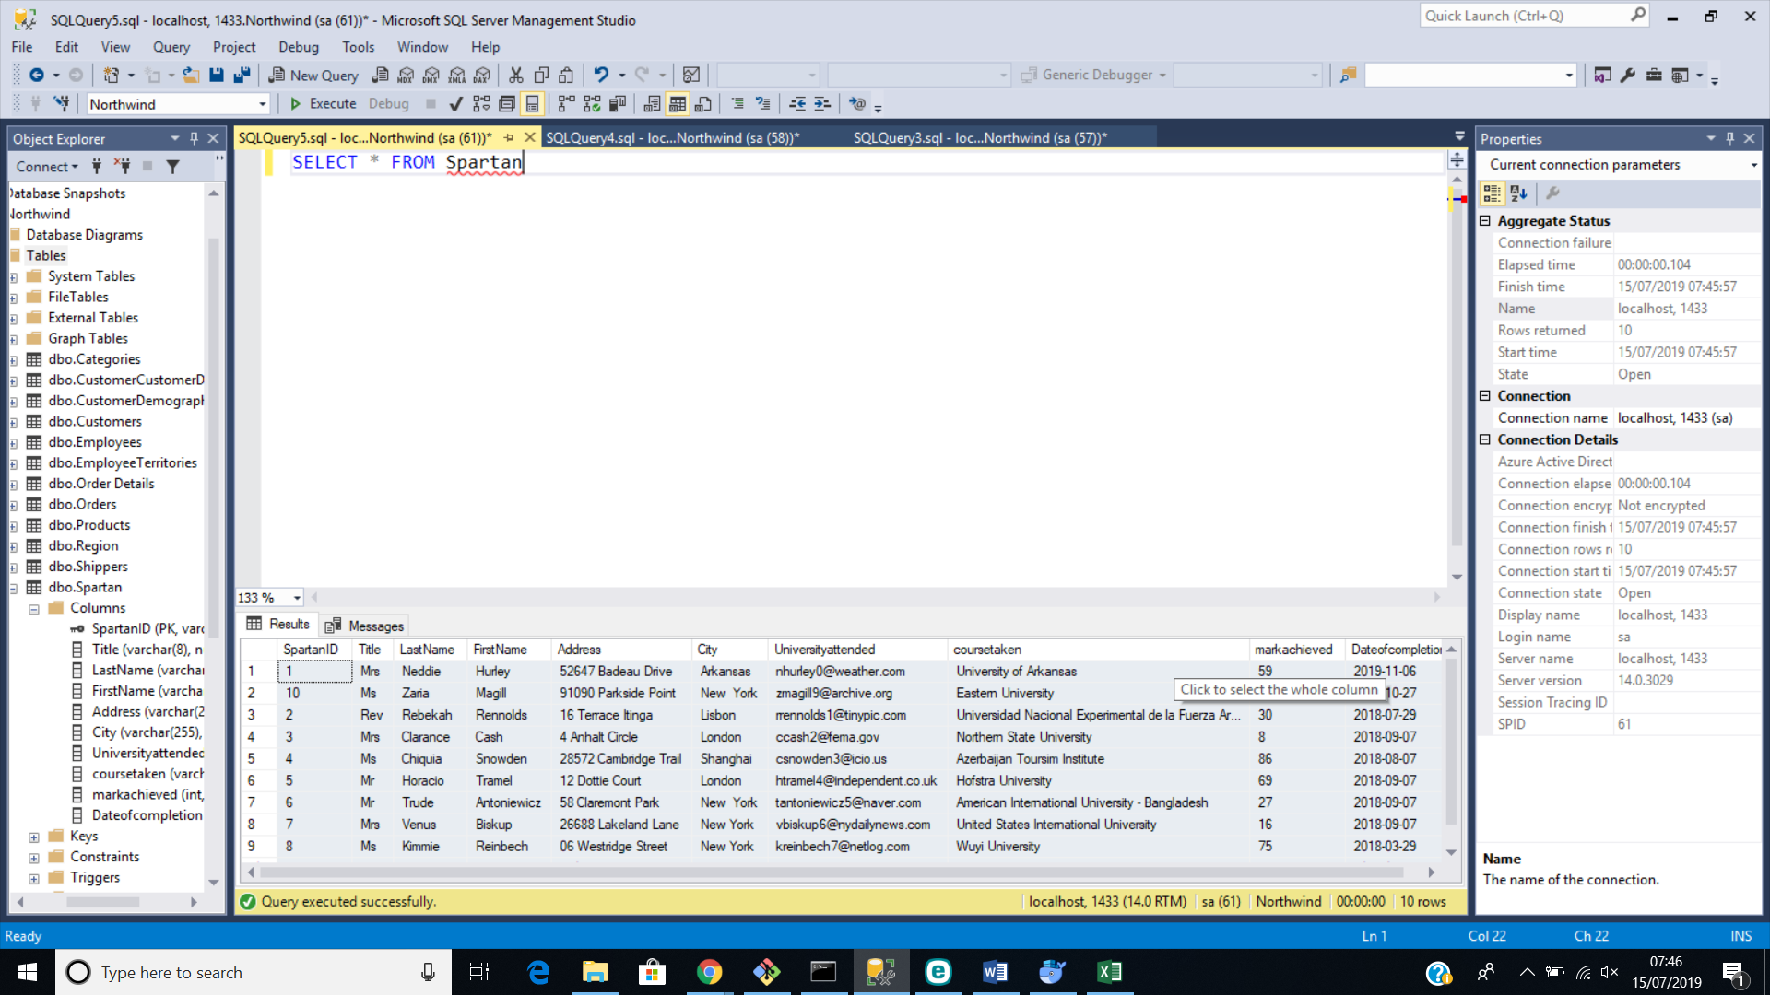

Exercise 3 – Northwind Data Analysis linked to Excel (30 marks)
Write SQL statements to extract the data required for the following charts (create these in Excel):
3.1 List all Employees from the Employees table and who they report to. No Excel required. (5 Marks)
3.2 List all Suppliers with total sales over $10,000 in the Order Details table. Include the Company Name from the Suppliers Table and present as a bar chart as below: (5 Marks)
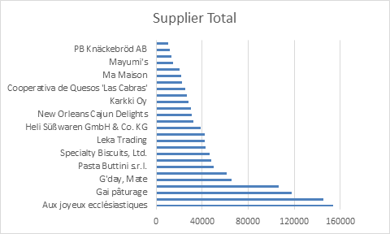

3.3 List the Top 10 Customers YTD for the latest year in the Orders file. Based on total value of orders shipped. No Excel required. (10 Marks)
3.4 Plot the Average Ship Time by month for all data in the Orders Table using a line chart as below. (10 Marks)
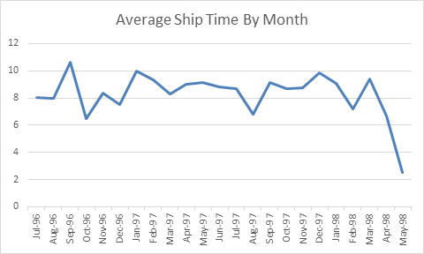

Standards (10 marks)
Remember to apply all the following standards:
- Use consistent capitalisation and indentation of SQL Statements
- Use concise and consistent table alias names
- Use column aliases to ensure tidy column headings (spaces and consistent capitalisation)
- Concatenate any closely related columns e.g. First Name and Last Name or Address and City etc
- Put comments throughout

